**Project 6 Coin Detection – Part 2 complete**

Name: __Joshua Hsueh__________________ Period: __3_________ Date: __4/26/2021________

Did you name your file l062.cpp (Lower case L, then 062)? ___Yes_

Did you create the edge matrix? _____Yes______

Did you create the gradient direction matrix? ___Yes________

Did you create the imagev.ppm (visual of votes)? ____Yes_______

Did you use Bresenham's line algorithm for voting? ____Yes_______

Does your application create coins.ppm file? ___Yes________

Does you code display on the screen and in results.txt a summary of your results? _Yes________

Did you test your code on terminal/gnu linux in c++11? ___Yes________

Run your code (the same code you submit) on the 3 images I provided (easy, medium, hard) then paste here the following:

* The initial image ( the one I provided), the imagev.ppm, coins.ppm you obtained running your code, copy paste here the content of your results.txt file your code created

1. For the easy image:

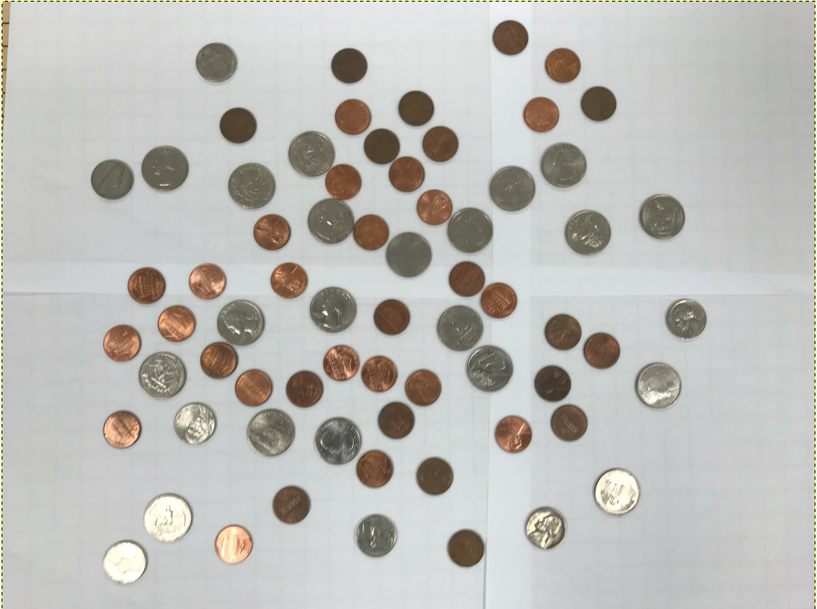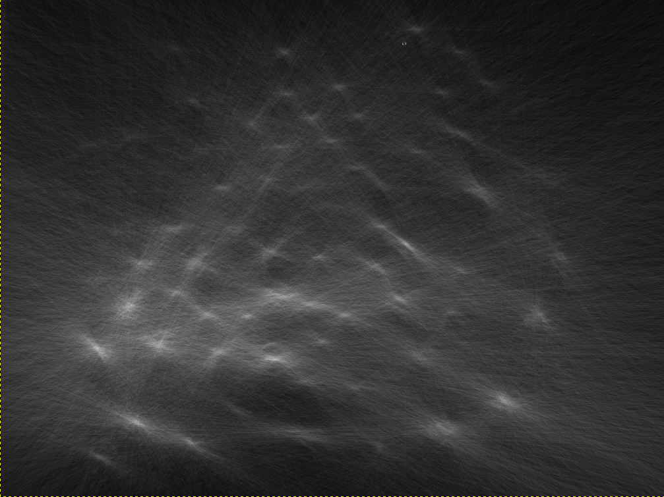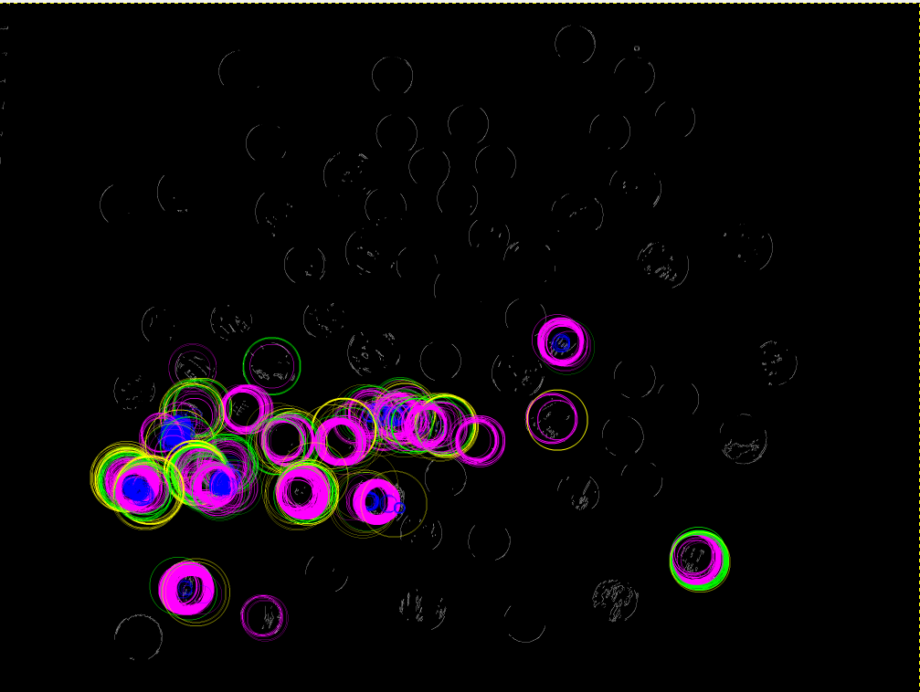

194 silver dollars, 359 quarters, 2455 dimes, 5283 nickels, and 1 pennies.Total sum: 793.41

1. For the medium image:

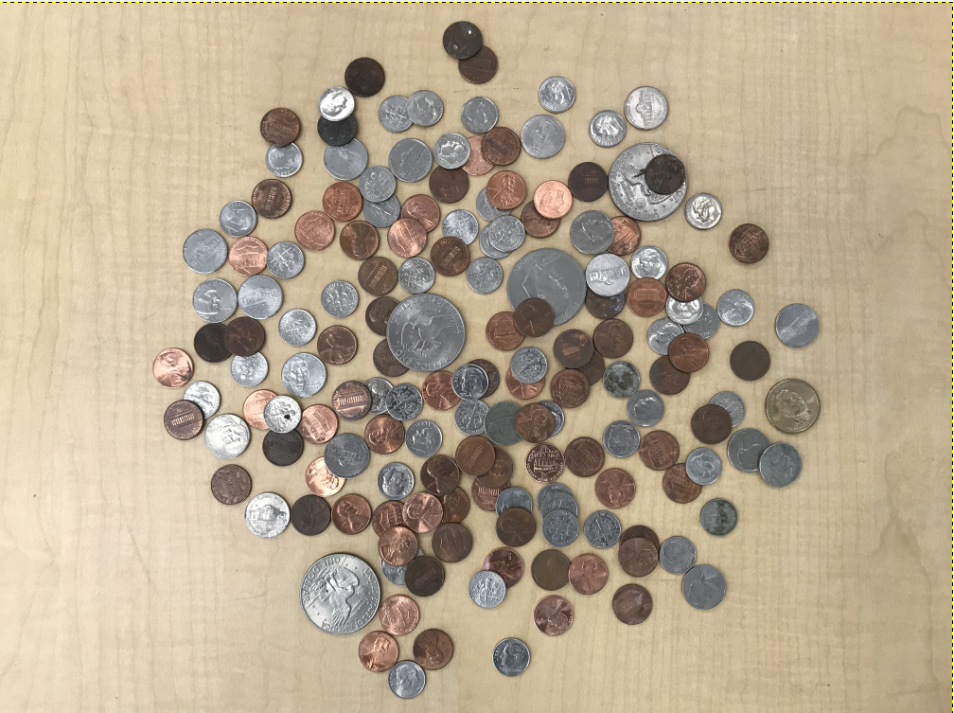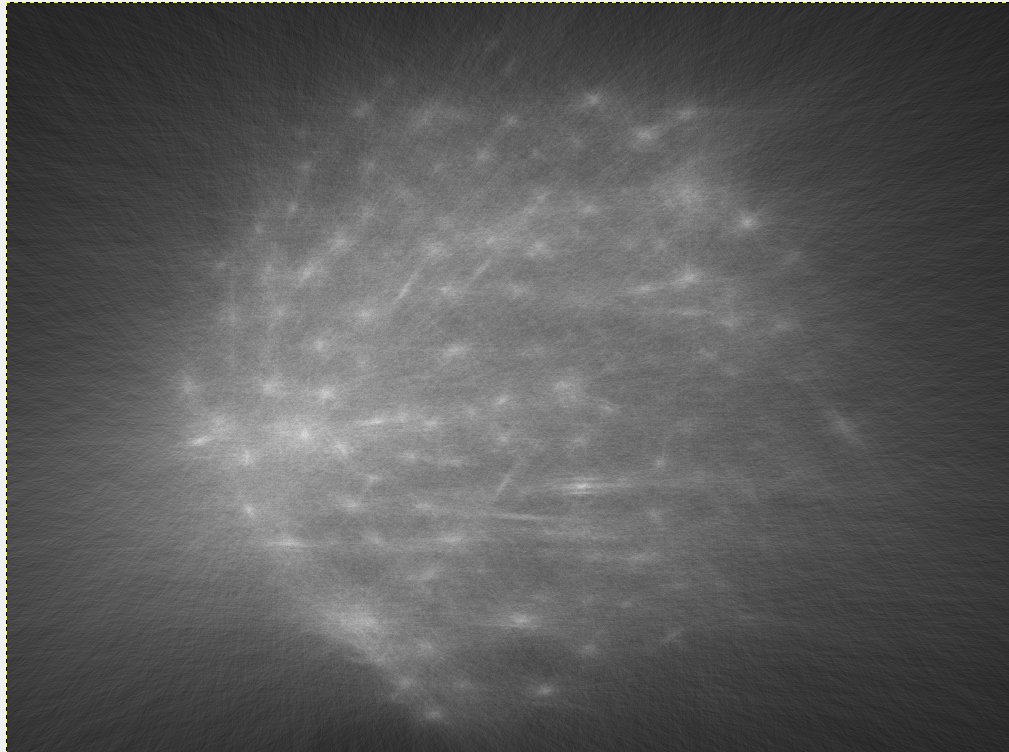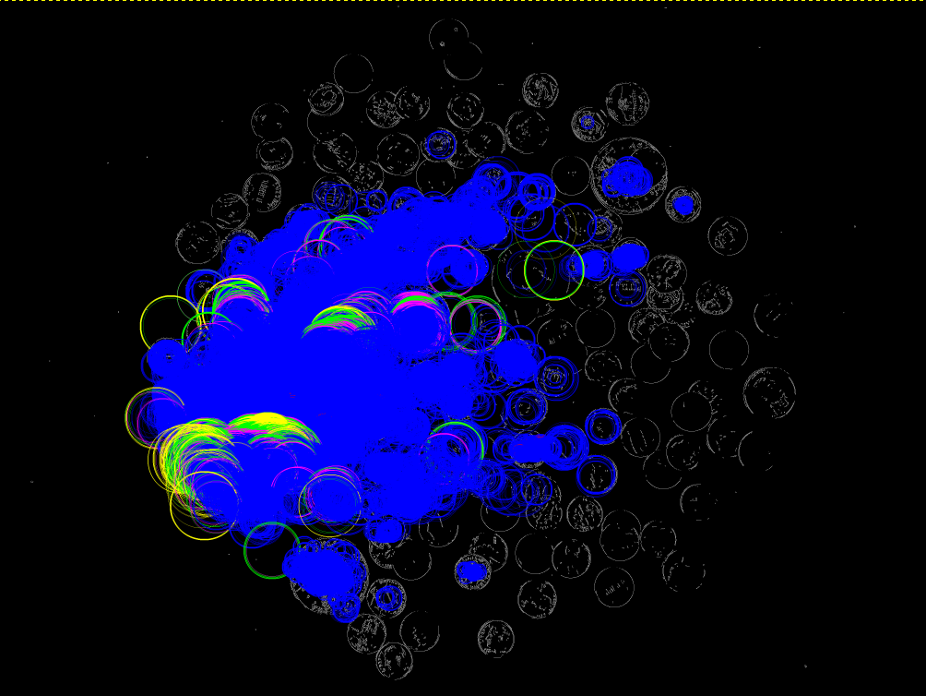

502 silver dollars, 1682 quarters, 492091 dimes, 1469 nickels, and 184 pennies.Total sum: 50206.9

1. For the hard image

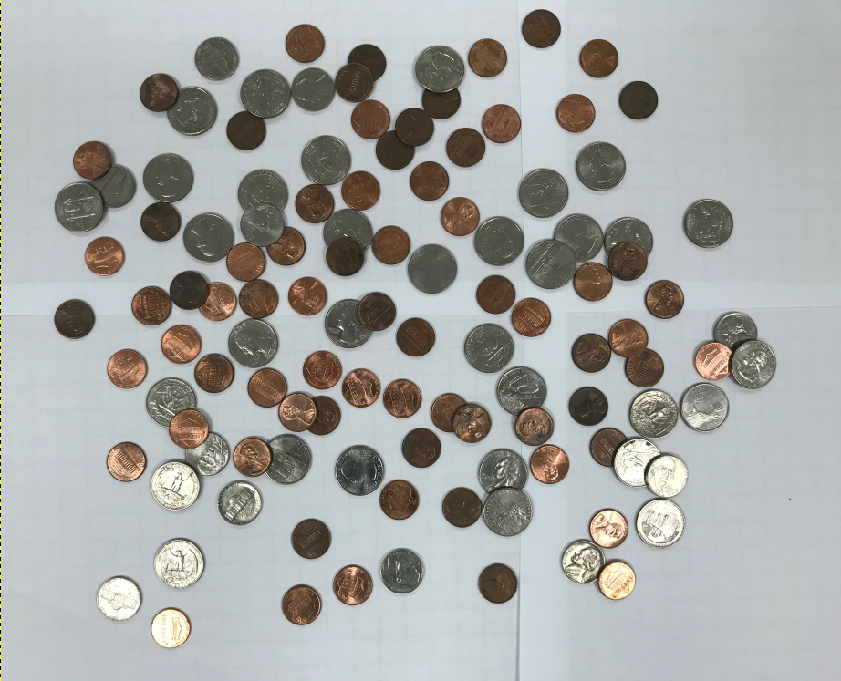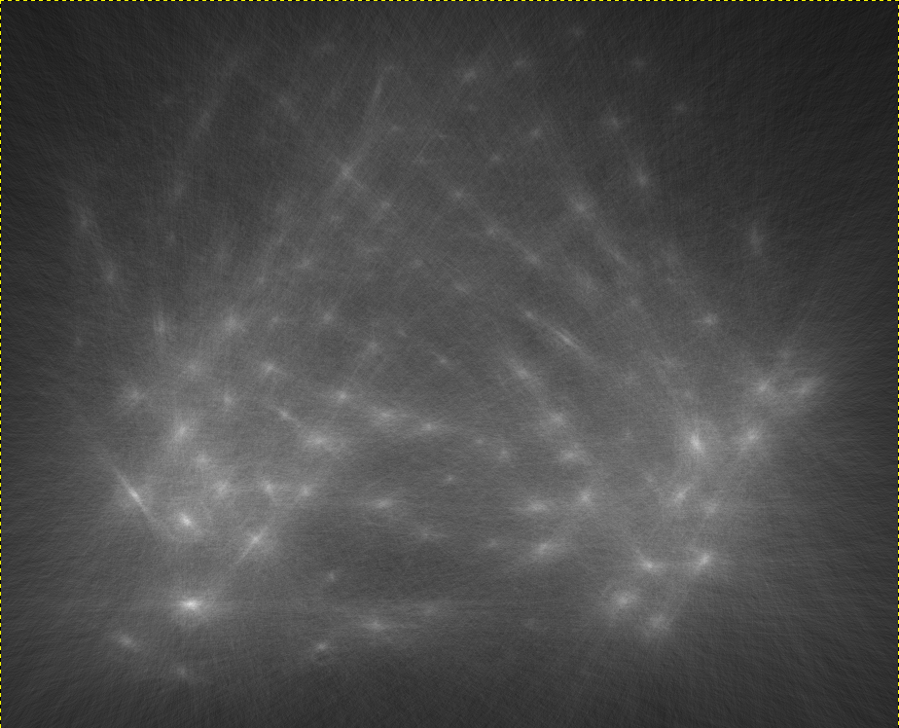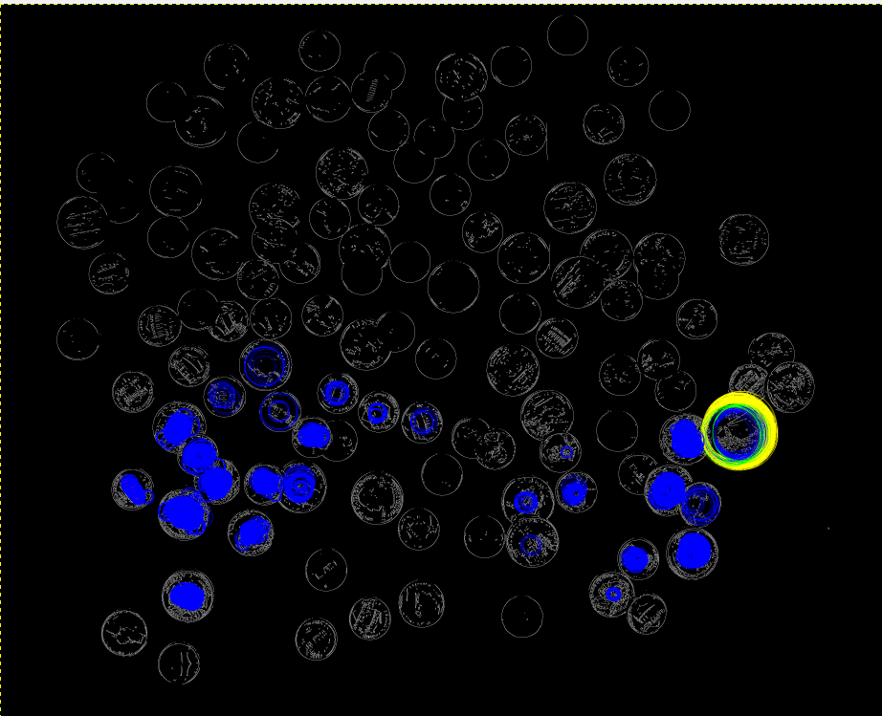

181 silver dollars, 40 quarters, 35541 dimes, 3 nickels, and 72 pennies.Total sum: 3745.97